UNIVERSIDAD NACIONAL DE QUILMES
INGLÉS II MÚSICA - Examen Parcial
Nombre:……………………………………………………Legajo:…………………………………………..Fecha:…………………………….
- Complete the blanks with the words given 20p.

thousands - opposite - displaced - suspended – through- removed- conducted - because – becomes – liquids -

2. Write a summary of the text in appropriate Spanish (30p)
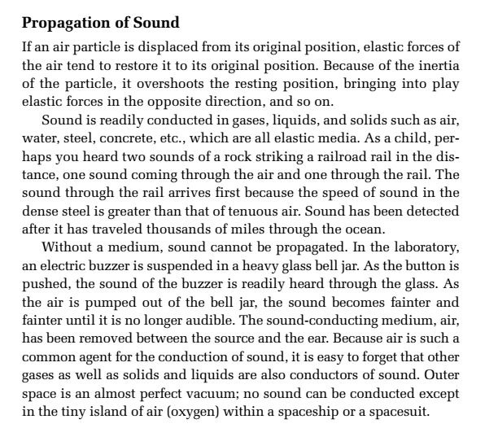

- Listen and complete the tasks bellow:

- What are the most important things to communicate to a group of musicians before they start playing? 3p...............................................................................................................................

- What dates are mentioned and why? 6p……………………..……………………………………………………………

…………………………………………………………………………………………………………………………………………………..

- Which languages are mentioned and why? 6p...............................................................................

…………………………………………………………………………………………………………………………………………………..

- Which tempos are mentioned and how they classify 5p.................................................................

…………………………………………………………………………………………………………………………………………………..
- Complete the following paragraph from the audio (20p):
Molto or assai mean very, and con ………………………… with. And piu means more, and poco means a little for example. This is how some of these might be ……………………………. together. Molto adagio is very slowly, or allegro assai would be very quickly.Let's talk about how they look in the score. In the score, they're only above the top stave. You can look in the ………………………..program that you use for those items that you can display only on the top stave. But in the ………………………………., they would go on top of the stave in each This is something that I'll just mention, there's a lot of…………………………….. that you try and communicate at the …………………………………… of a piece. And sometimes, you need to move things around to accommodate what you're …………………………………. to do. But, first and foremost, you left align this with a time signature. Then, if you decide to use both the tempo marking and the metronome marking, the tempo text …………………………………… goes first. And then, the metronome marking comes second. In terms of the style, you're going to bold and not ………………………………. the text you're using.They should be as large or larger than any other text …………………………………. that you're using.
- Write these last paragraphs into appropriate Spanish (10p)

