UNIVERSIDAD NACIONAL DE QUILMES

INGLES HOTELERO I - EXAMEN PARCIAL

NOMBRE Y LEGAJO:.................................................................................... FECHA:............................

- Write a telephone conversation to complete the following form:

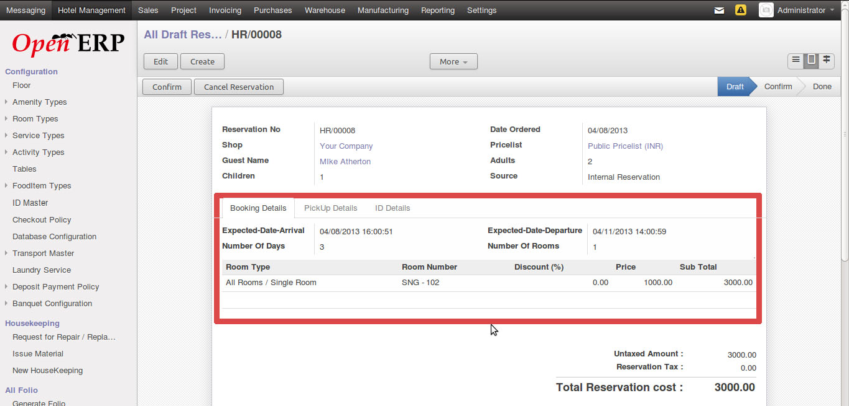

2) Write a dialogue about the hotel. Include some of the following topics: accommodation, characteristics, facilities, services, prices, timetables, room description. Use the pictures to help you.
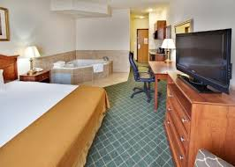
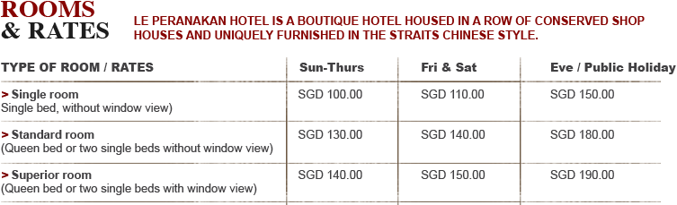
3) Look at the leaflet and write a dialogue including these functions: greetings/offering help/answer with information required, asking about types of menu, opening dates and times, location and facilities, methods of payment, making and taking a reservation



4) Listen to two dialogues and write in Spanish: situation, participants, function, numbers-referent, names, other details.
Audio 1 Audio 2
Situation / Place
Participants n° and roles
Name/s
Date/s
Price/s
Other details

